About data collection for the case study.

Key phrases: 国际警务合作, 警大，外交维和培训`

Please take the next two weeks and gather all the information that you can, and write ~2-3000 words of description that answers the following:

What is the history of the college where the peacekeeping police are trained?  What is its relationship with MPS, and how has this changed over time?  (Are there other institutions that train police and/or police peacekeepers in China, or is this the only one? A major one? Try to characterize where it fits within the Chinese police education system.)

China sees it necessary as a responsible power to participate heavily in UN PKOs. It began to shift towards international police cooperation in the 1980s with a large development period in the 21st century (朱, 2020). In 1984 it retook its seat in Interpol (Xi, 2017) and it deployed its first UN PKO operative to Namibia in 1980 (Gill & Huang, 2009). Since then, it has entered a new development period in the 21st century with official centers for domestic and foreign police training, most notably the Chinese Peacekeeping Training Center in Langfang, Heibei. The PRC’s concentration on “police diplomacy” as mentioned by Zhu essential to modern “multi-level” diplomacy, has led to the government’s investment in specialized centers and colleges for foreign and domestic police officer training. Linked under the MPS, the structure allows for domestic security trainings to intermingle with international diplomacy in asymmetric power dynamics unrelocatable by most Western countries like the United States. The international police cooperation layer of diplomacy is obviously critical to China’s “shared future for all mankind” with the chronological alignment of increase financial and personnel investment in UNPKO and President Xi’s speech mentioning increase, yet Chinese academics bemoan a lack of study and transparency (朱, 2020, p. 91). Furthermore, Chinese academics and President Xi cite an increased transnationalism in crimes with developments in fields like terrorism and cybercrimes as reasons to concentrate on cultivating international security relations through policing (朱, 2020; 林 et al., 2024).

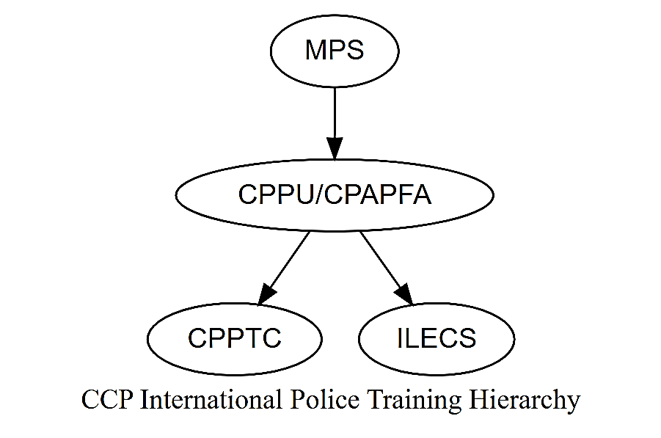

Figure 1International police training is concentrated on the CCPU campus in China

Another aspect of Chinese foreign and domestic PKO training is its perceived responsibility as a responsible power [[CITE]]. It is a leader in UNPKO deployment in the UN and UNSC [[CITE]] and a known user of strategic nontraditional asymmetric land power (Greitens, 2024). President Xi has increasingly used the ambiguous phrase “community with a shared future for mankind” as a foreign policy guide (Zhang, 2018), from the first time in a 2015 speech in Russia to even in the 70th United Nations General Assembly (张 & 赵, 2023). The PRC has established the China Peacekeeping Police Training Center (中国维和警察培训中心, CPPTC) to support its deep financial and soldier investment in UNPKOs [[CITE?]].

The Ministry of Public Security (MPS) founded and is directly over the Chinese People’s Armed Police Academy, known as the China People’s Police University (CPPU) since 2018, which physically houses and is directly over the CCPTC (*About the Chinese People’s Armed Police Force Academy*, 2019; 王, 2023). In 2001, the PRC established the China Peacekeeping Police Training Center (CPPTC) in Langfang, Hebei to the tune of $21 million dollars (International Cooperation Department, 2013). Of note, the International Law Enforcement Cooperation School of the MPS is also located on the China People Police University’s campus, directly under the CPPU and thus the MPS (*China People’s Police University*, 2019; 王, 2023). The CPPU “mainly undertakes the education and training of officers for border control, fire control, VIP protection, and UN peacekeeping” (*About the Chinese People’s Armed Police Force Academy*, 2019).

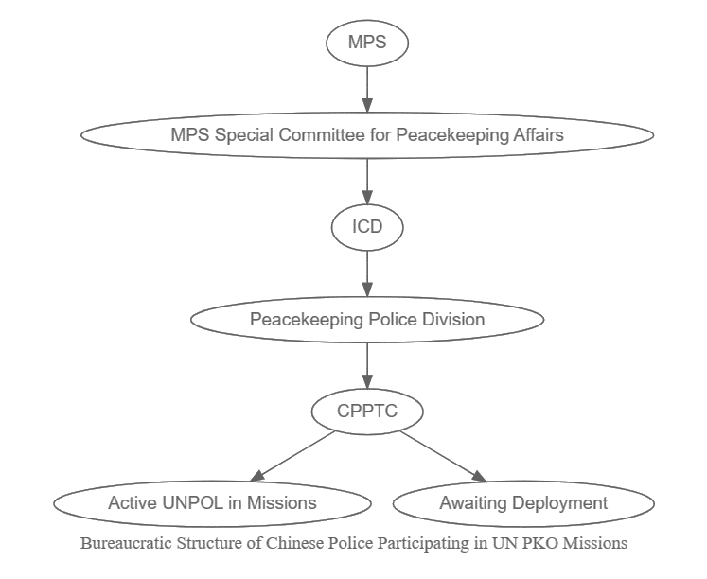

Figure 2 Chinese peacekeeping bureaucratic hierarchy according to a 2013 ICD presentation recoded by ASEAN.

According to a presentation written by the International Cooperation Department (ICD) of the Ministry of Public Security in October 2013 and presented at the ASEAN Regional Forum, the bureaucratic structure of Chinese peacekeeping police is that the top leadership is in the MPS, then through a special committee it filters down through the ICD before the Peacekeeping Police Division, and then finally the CPPTC oversees UN Police (UNPOL) in missions and any candidates who are waiting for deployment (International Cooperation Department, 2013).

The CPPTC is under the CPPU, which is directly under the MPS.

* + Xi’s global vision for national and state security work. “As China plays and increasingly active role in reforming and improving the global governance system, the UN peacekeeping mechanism will greatly benefit from Chinese resources and wisdom. In other words, in the future, China will contribute not only to personnel and budget, but also “Chinese approaches” to peacekeeping” [[Should be a China Daily article]].
  + “China also now hosts the Global Public Security Cooperation Forum (GPSCF, formerly the Lianyungang Forum), an MPS-backed effort to expand security cooperation among law enforcement agencies worldwide and to promote the export of China’s security and surveillance technologies” (greitens 2024)

MPS 🡪 International Cooperation Department (ICD) 🡪 Peacekeeping Police Division 🡪 China Peacekeeping Police Training

However, this article states that It was founded on the grounds and under the jurisdiction of the Chinese People’s Armed Police Academy (CPAPA)

Tuesday

* What kind of international training generally does this college do?  (I believe this college is the main site of MPS' international education/training programs, but please look to confirm that.)  How big is the program, focused on which countries, etc?

A goal of the CPPU where the CPPTC is located is international influence (*China People’s Police University*, 2019). Is thus very active in learning from and teaching foreign police officers. The center has a partnership with thirty foreign official colleges, including the French National Fire Officers Academy and the Russian University of Krasnodar (*China People’s Police University*, 2019). As of 2019, it had trained over “1,700 foreign police officers from over 80 countries (regions), contributing wisdom and strength to the international law enforcement and security cooperation” (*China People’s Police University*, 2019).

Wednesday

* When and how did this college get involved in the training of peacekeeping police?  (Please look at this for both Chinese police peacekeepers, and the international dimension, and try to get a precise timeline for each)

Thursday

* Specifically for UN police training: what are the current programs/training activities run at this college?  What countries have participated, with how many people, over what time frame, for what missions?

Friday: Edits and Send-in

Probable sources for this include the college's website, materials from MPS, Xinhua and other state media, Police Daily (in Chinese), other policing journals accessible through CNKI, reports/research at various Chinese think tanks, etc.